COEUS LITE IRB SUBMISSION SYSTEM MANUAL APPENDIX

UPDATED MARCH 21, 2016

Creating an Amendment to a Currently Approved Protocol 2
Modifying Attachments
Uploading a New Document for Review by the IRB

Deleting a Pending protocol 6

Withdrawing a Submission 8

Create Renewal 8

Reviewing Revisions Required by the IRB 11
Responding to the IRB When Revisions Are Requested
Modifications to Previously Uploaded Documents

Other Protocol Actions 17

Closing your study …………………………………………………………………………….

CREATING AN AMENDMENT TO A CURRENTLY APPROVED PROTOCOL

Click on My IRB Protocols.

Click on All Protocols to see the full listing of protocols and their current statuses. Select approved protocol you wish to work with. Note the protocols and related information can be sorted by clicking on any one of the column headings. Example: Statuses may be sorted in ascending/descending alphabetical order by clicking on the column heading Status.

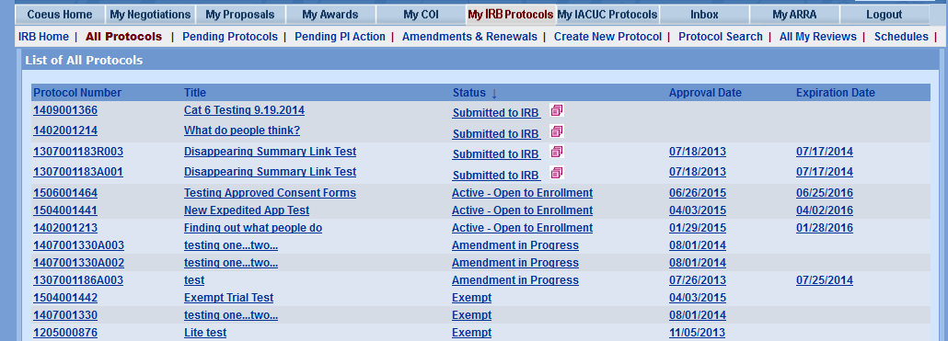

Click on New Amendment in the column on the left-hand side. This will open the
Amendment Summary window.

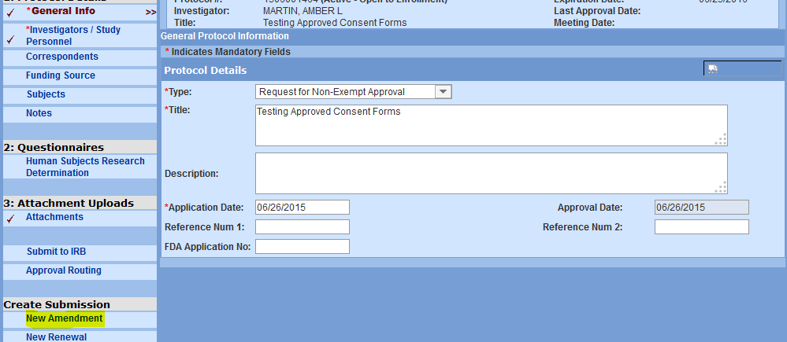

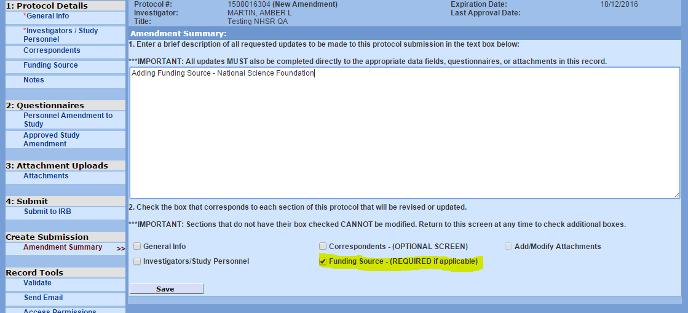

You must provide a brief but detailed summary of the amendment in the window. For example, be sure to note the names of new individuals being added to the research team and who they are replacing. Click on all the applicable checkboxes for those items being changed. Note that clicking on the box opens up the protocol record for the information to be edited in that tab.
Click on Save when complete. Note an A00x suffix is applied to the protocol number. This refers to the sequential number of amendments for that particular protocol. The A suffix is dropped once an amendment is approved by the IRB. This means that the changes proposed in the Amendment have been incorporated into the Protocol you can still submit other amendments or renewals by searching and selecting the base protocol number.

To change the information in the protocol record, click on the applicable tab in the column on the left-hand side. The window for the tab chosen will open, allowing for selection and/or entry of items to be added or removed. Save when complete.

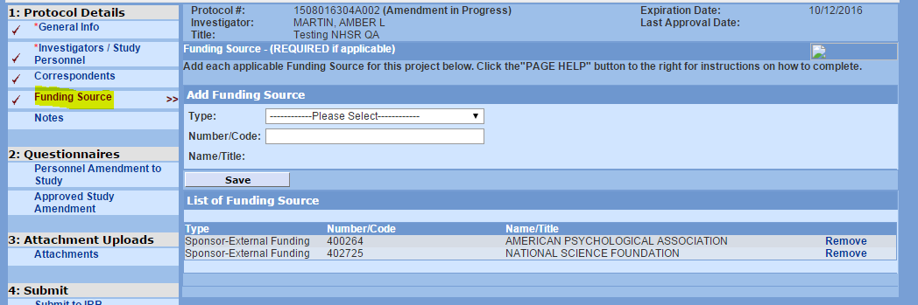

Select the General Info Tab. This will bring up the IRB Amendment Questionnaire. You must complete the Amendment Questionnaire before submitting to the IRB.

Click Submit to IRB and select Amendment as the submission Select submit to route your request to the IRB for formal review.

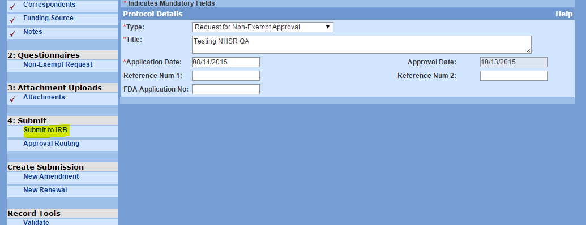

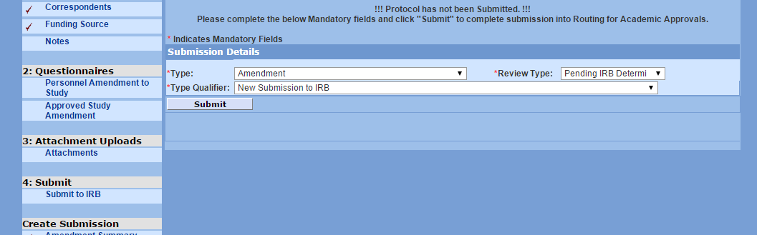

MODIFYING ATTACHMENTS

Be sure to have clicked on the Attachments box on the Amendment Summary screen. Click Save.

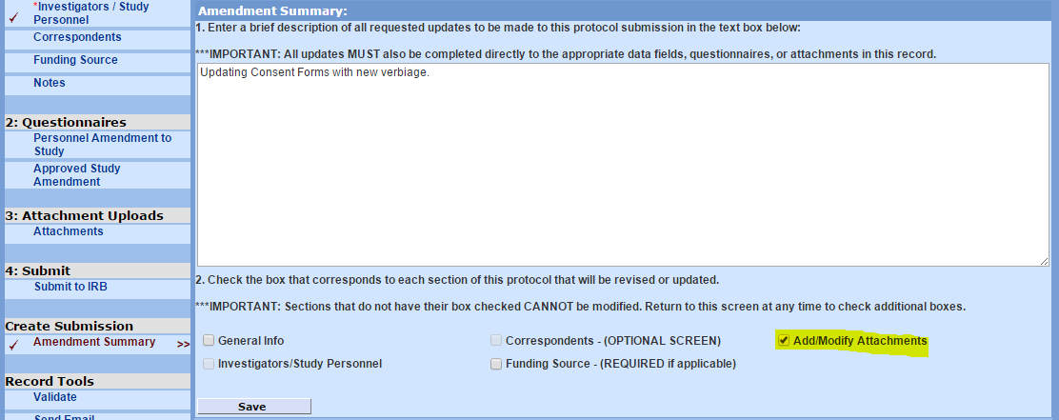

Select the Attachments tab from the left hand column to modify a document that has previously been uploaded into Coeus IRB. To modify the document click Amend located to the right of the document listing.

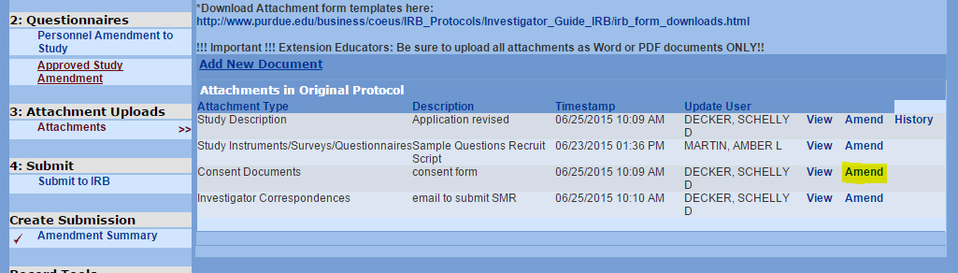

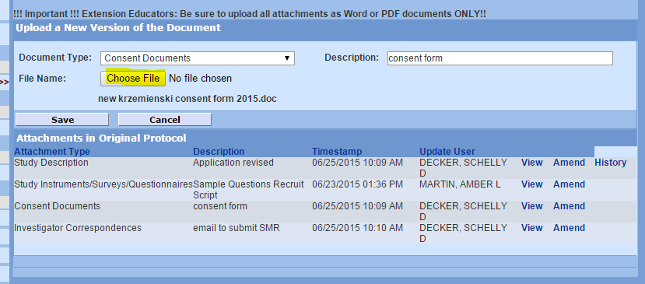

Note that the name of the Document Type and the Description remains the same, as this is the document that the user is modifying. (See grayed out text in image above.) Click Choose File to select and upload the modified version of the document from the user’s computer files or travel drive.

UPLOADING A NEW DOCUMENT FOR REVIEW BY THE IRB

Click Add a New Document to upload a new document, for example, adding a new consent document because a new population has been added to the project. Select the appropriate Document Type from the drop down box. Enter the name of the document into the Description field. Be sure to use the name that the document is commonly referred to by the research team. You may also want to add a date for clarity purposes. Click Choose File to upload the new version from the user’s computer files or travel drive.

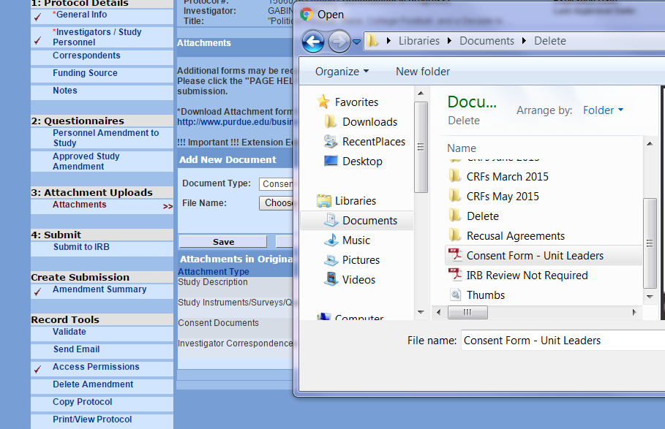

Click Save.

Click Submit to IRB from the left hand column to submit the amendment to the IRB for formal review.

DELETING A PENDING PROTOCOL

A protocol or amendment submission is considered as pending until the time a user submits the amendment to the IRB. Protocols can be deleted before they are submitted. Once submitted they cannot be deleted.
To delete a protocol, click on Pending Protocols from the main IRB menu. Then click Status to bring up the alphabetical listing of protocols by status. Search for the protocol you wish to delete.

Click on Delete Protocol from the left hand column.

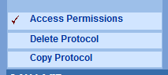

The user will be prompted with a message that asks whether or not you wish to delete the protocol. Click OK to say yes. Click Cancel to say no and continue working.

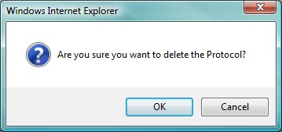

To delete an Amendment in Progress:

Bring up the Amendment Summary by double clicking the protocol Amendment number.

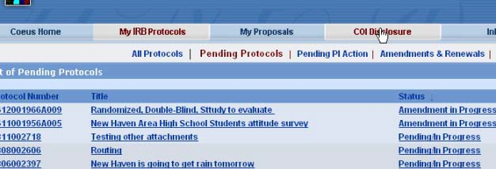

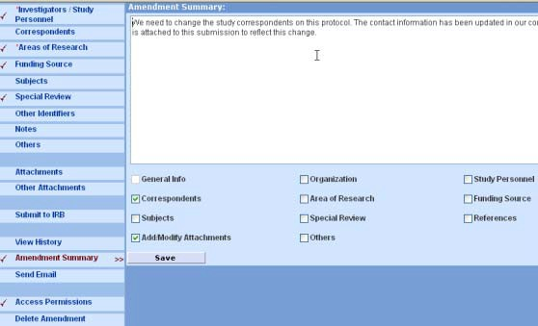
Click on Delete Amendment from the left hand column to delete the amendment summary. The user will be prompted with a message that asks whether or not you wish to remove the amendment. Click OK to say yes. Click Cancel to say no and continue working on the amendment.

WITHDRAWING A SUBMISSION

The user can withdraw an initial protocol, an amendment or any other submission up until the time the protocol submission status is In Agenda. “In Agenda” means that the IRB is reviewing the protocol.

To choose the submission the user wishes to withdraw, search for the protocol submission by clicking on All Protocols, then searching the Status equal to Submitted to IRB. Double click on the submission (Renewal, amendment, renewal/amendment or Initial).

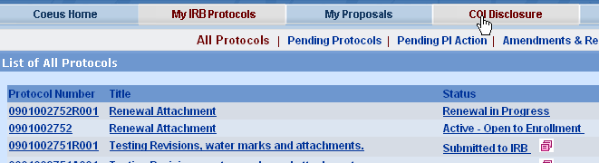

To withdraw a submission, choose the Submit to IRB from the left hand menu of the submission record. Then choose Withdraw Submission.

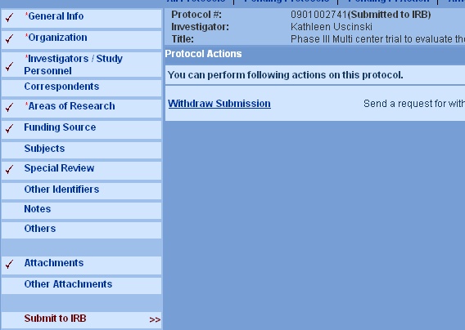

CREATE RENEWAL

Use this submission type to request renewal for a currently approved research protocol. If you need to make changes to the currently approved protocol, consent document(s) or other protocol documents then you must use the Renewal submission.

Click on My IRB Protocols.

Click on All Protocols to see the full listing of protocols that are already approved. Select the protocol you wish to work with. The information can be sorted by clicking on any one of the column headings. Example: Expiration dates may be sorted in ascending/descending order by clicking on the column heading Expiration Date.

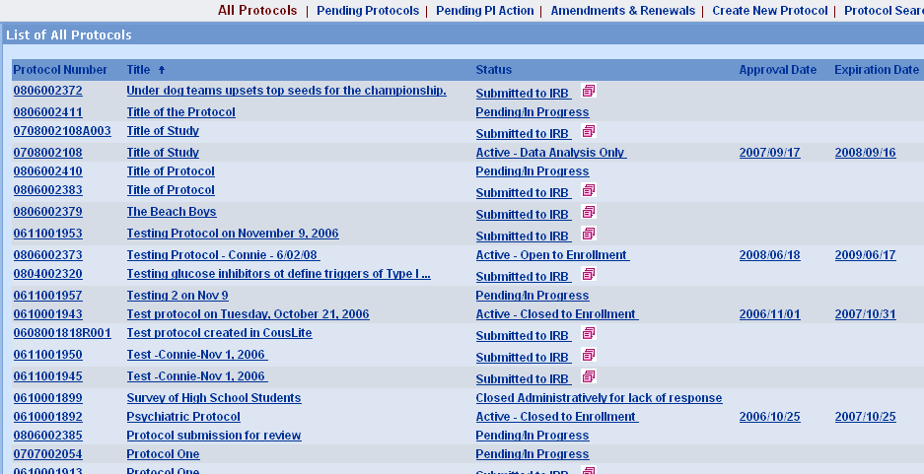

Double click on the protocol you wish to work with. This will open up the protocol record. Click the New Renewal button from the column on the left-hand side.

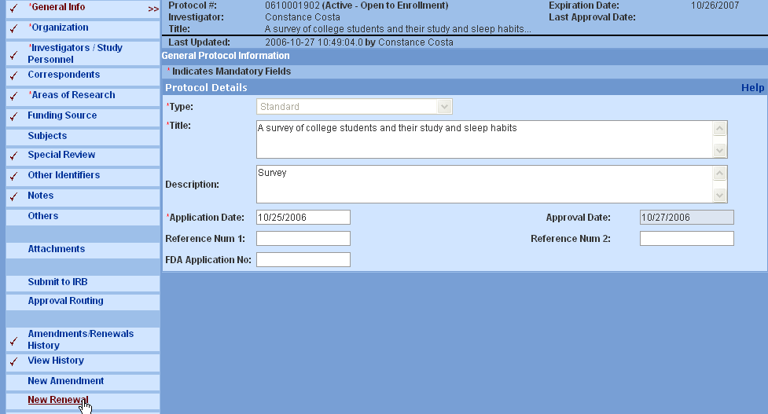

If there are pending renewals for the protocol, a window will pop up to indicate that these submissions already exist and inquire if you want to create a new
renewal. Click OK to continue or click Cancel. (Note: Cancel means no.)

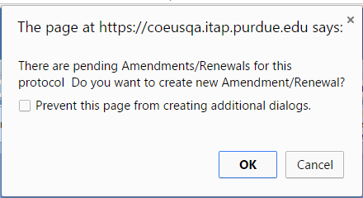

The Renewal summary window opens.

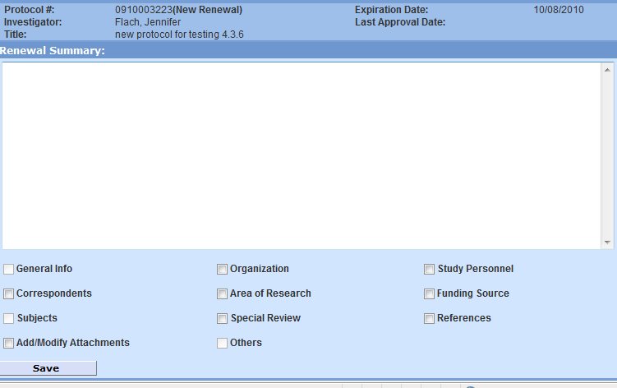
Type your comments in the Renewal Summary box. For example: “Research is progressing as planned.
Save when complete. Renewal has been created. Select the General Info Tab. This will bring up the IRB Continuing Review Questionnaire.
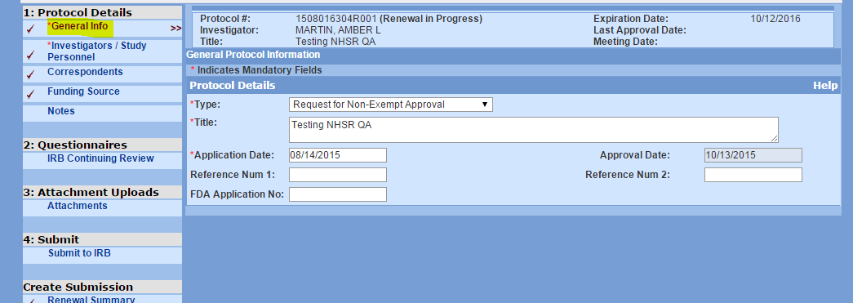

Select the IRB Continuing Review Questionnaire and work your way through the questions until complete.

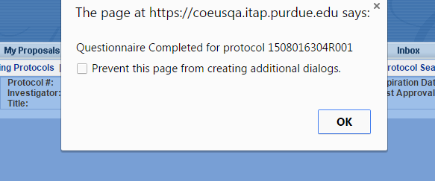

If you need to upload attachments, make sure that the Add/Modify Attachments box is checked in the Renewal Summary tab. Then select Attachments from the left hand column tab to upload. Select the appropriate from the Document Type drop down box. Type in the Description of the document. Then use Browse to upload the completed documents from your computer files. Click Save.

Click Submit to IRB to submit your request for renewal to the IRB for formal review.

REVIEWING REVISIONS REQUIRED BY THE IRB

Investigators are notified when revisions are required by the IRB so that approval of the protocol submission may be eventually granted. Investigators can view these requests for revisions through the Coeus IRB system.

After signing into the Coeus Web page, click on My IRB Protocols. Select the Pending Protocols tab. Protocols requiring revisions are assigned a Status noted as either Specific Minor Revisions Required or Substantive Revisions Required.

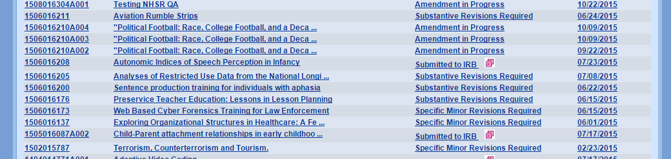

Investigators may also view protocols requiring action by clicking on Pending PI Action tab.

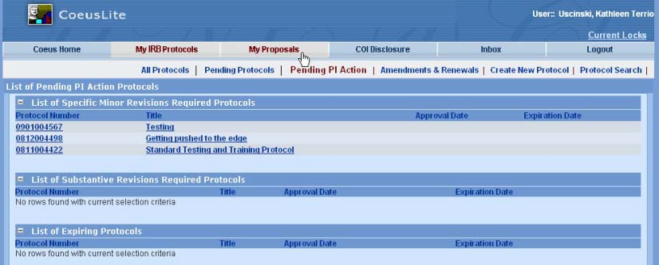

In either screen, click on the protocol to open the protocol record and then click the View History in the left hand column. This will permit the investigator to view the actions and correspondence with the IRB.

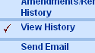

Note the Specific Minor Revisions Required in the Description field. Click View to see the quick comments from the IRB. To see the full correspondence click open the + next to the Specific Minor Revisions Required.

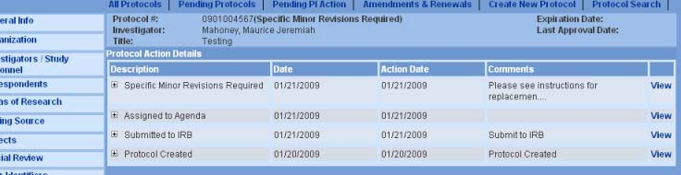

This screen provides submission details related to the IRB review. Note the name of the IRB Committee and the Committee date of review (Schedule Date) are listed on this screen. Click on View on the line that notes Specific Minor Revisions Letter under the Correspondences section to view the actual letter.

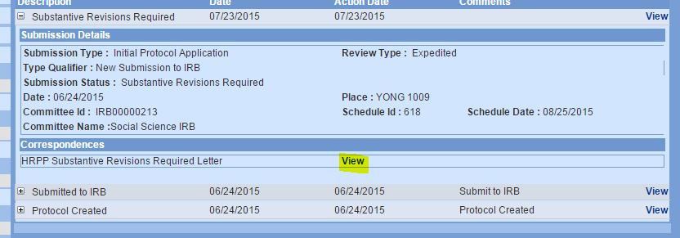

RESPONDING TO THE IRB WHEN REVISIONS ARE REQUESTED

The investigator is required to provide a written response to the IRB addressing each of the revisions requested by the IRB. In some cases only a response (memo or letter)

from the investigator needs to be uploaded into the system and sent to the IRB as it sufficiently addresses the IRB’s request for clarification.

In other cases however, changes are required to the protocol documents that were previously sent into the IRB for its initial review. As an example, the IRB may 1) require specific word changes to Consent Documents or 2) require that the investigator change interventions or procedures in the protocol. In the case of example #1; modifications to the originally submitted consent document must be made and re-uploaded into the system for review by the IRB. Similarly, in the case of example #2, the questionnaire and perhaps the consent document would require modification and a re-upload into the system for re-review by the IRB.

While the comprehensive changes required of the investigator are noted in the IRB’s response, an IRB may request that some changes, such as those requested in consent documents, are noted in a track-changed Word version of the document that is returned to the investigator by the IRB at the time it issued the Revision request. In this case, the investigator must be sure to review all the changes requested by the IRB and then upload a new version of that document both in Word.

Note

Final approval markings are automatically applied to all Adobe (pdf) protocol-related documents when the IRB approves the protocol.

To upload the investigator’s letter of response, Click on Attachments from the left hand column. Select Add New Document and use the drop down box to select the Document Type and under Description you can indicate that it is a response and the date. Example: Response to SMR of 01/23/2009. Choose File to upload the document.

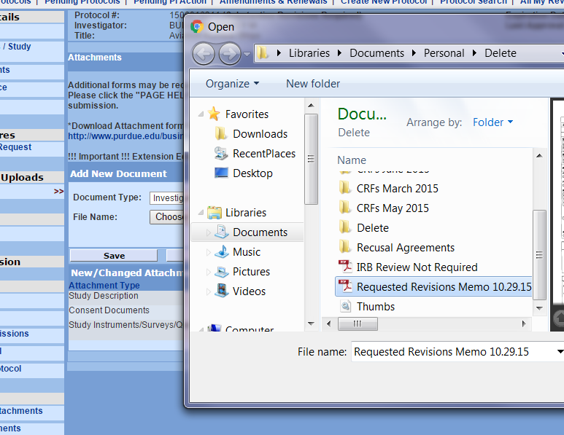

Click Save.

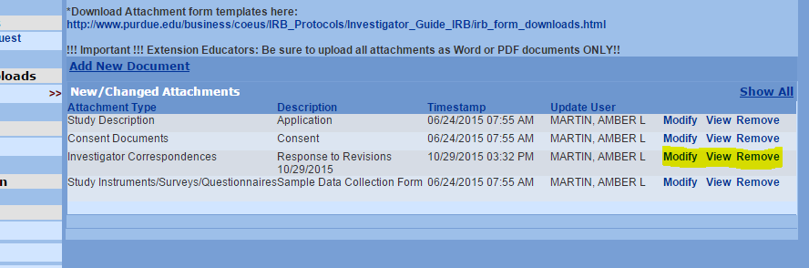

Note, the investigator can Modify or Remove the response document if changes are required prior to submitting it to the IRB.

MODIFICATIONS TO PREVIOUSLY UPLOADED DOCUMENTS

To view changes requested by the IRB that have been inserted into the documents already uploaded into the system and/or to modify documents previously submitted, select Attachments from the left hand column.

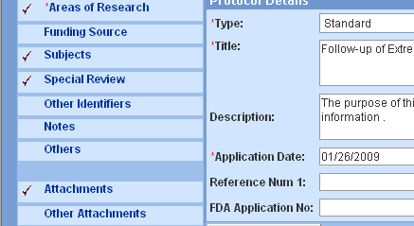

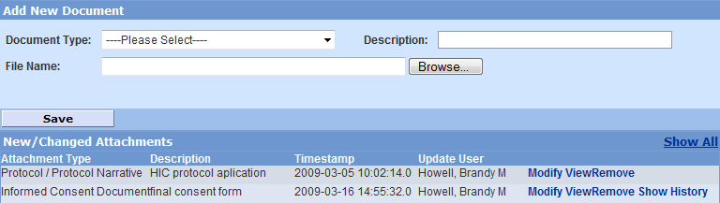

Note
The version of the document edited by the IRB (IRB User in this example is Howell) is the only version viewable as it was the last one edited in this example.

To see the version originally submitted by the investigator or the history of this particular document, click Show History. This will bring up all versions of the same document that were either previously submitted by the investigator or edited by the IRB.

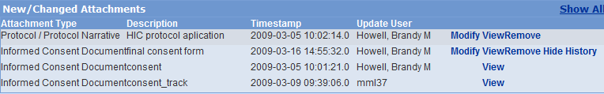

Note
The screen opens to permit investigators to add additional documents. However, the user must modify the currently uploaded document in order to re-upload it as the new version or revised version. This will also help to ensure that the IRB and PI acknowledge the editing history of each document. In other words, prior to uploading a new version of a document requiring revisions, the investigator first must modify the previous version.

To modify the document(s) requested by the IRB click Modify.

Prior to uploading a modified version of a document for submitting back to the IRB, the investigator will need to review the IRB edited version. This will help to ensure that the
investigator has reviewed all revisions requested by the IRB. The investigator may accept all changes or may make additional changes. The changed version should be saved to the investigator’s computer files. The investigator may choose to rename
the document or add a date to help with identification. Using the Modify feature will ensure that any changes in title are still associated with the same document and will be recorded in the history.

Choose file to browse your computer and choose the version of the document with the changes you made. Click Save.

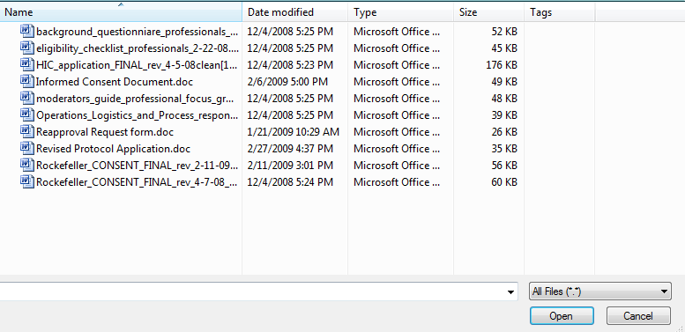

The document that has been modified now displays, replacing the document from the IRB.

When all attachments and the response are uploaded, then the response can be submitted back to the IRB. To do so, select Submit to the IRB from the left hand column.
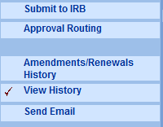

Click Submit for Review.

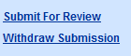
Choose the Type: Initial Submission, Renewal or Amendment.
For Review Type, choose Pending IRB Determination.

For Type Qualifier, choose Revisions Requested by IRB

Click Submit.

OTHER PROTOCOL ACTIONS

Depending upon the status of a protocol, the investigator is able to take certain actions on the protocol. This is done by clicking on the My IRB Protocols tab at the top of the page. This will open the list of actions:

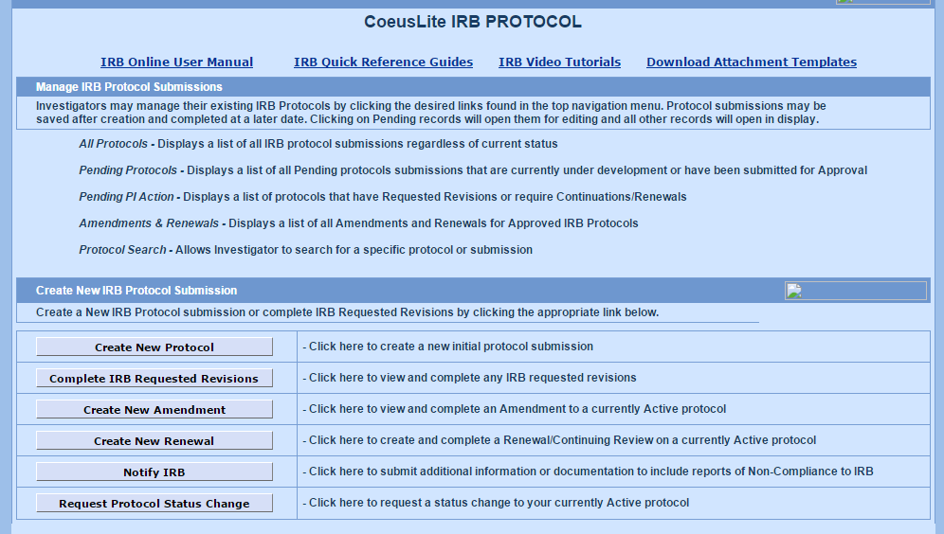

To request to close a protocol to enrollment, click Request Protocol Status Change.
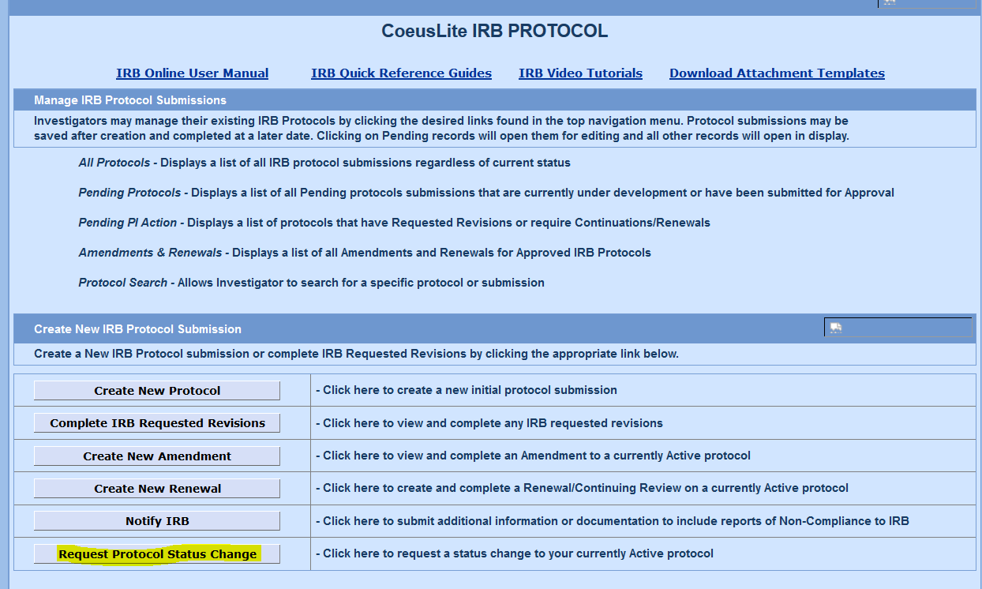
Select the study you wish to close.
Select Request to Close.
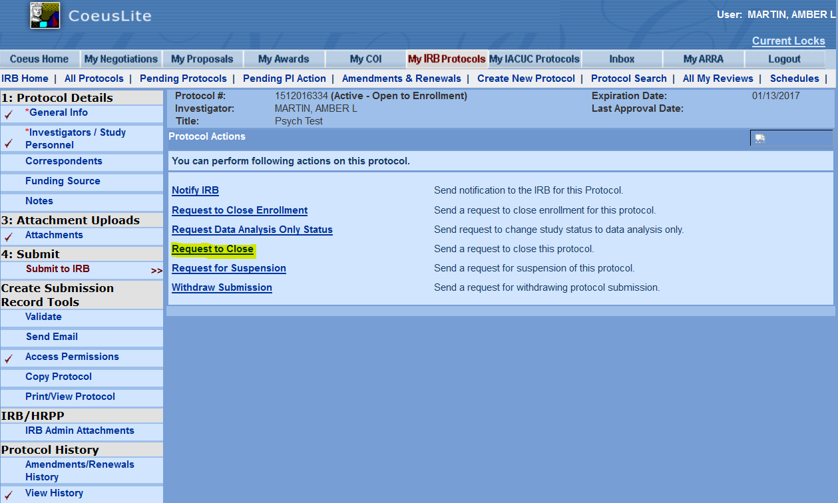
Save Submission Details.
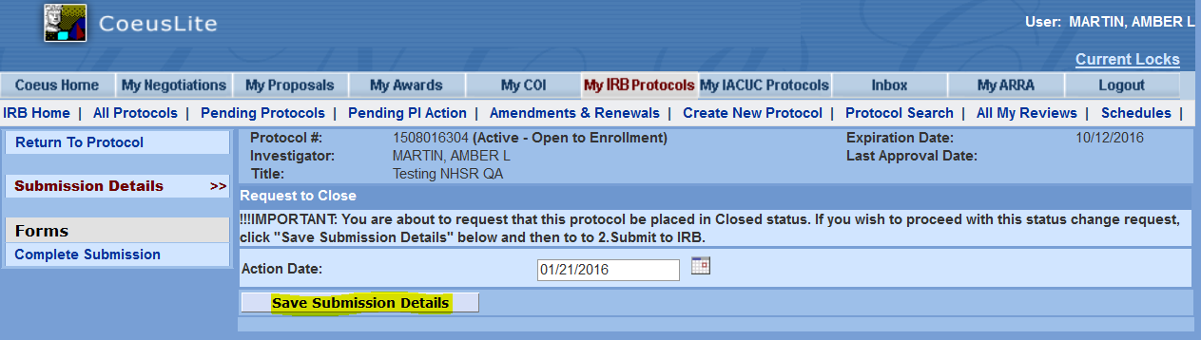
Select Closure Request.
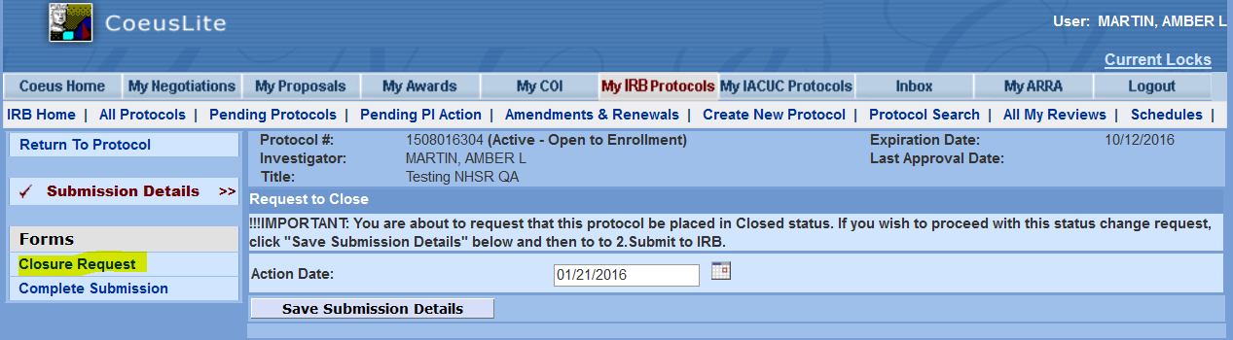
Complete the Questionnaire.
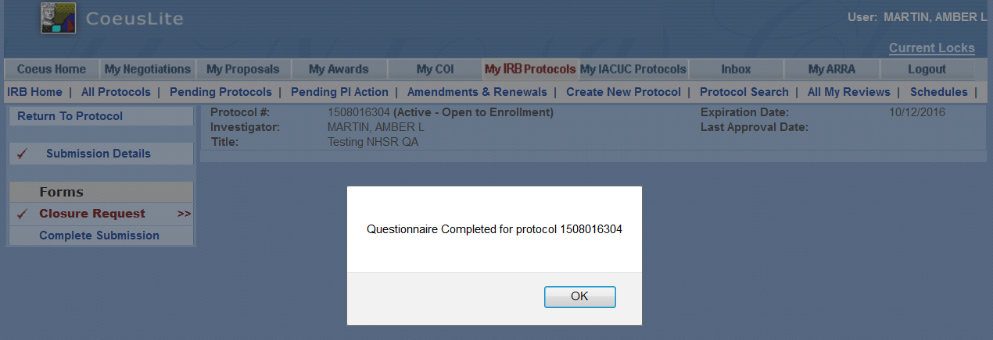
Select Complete Submission.
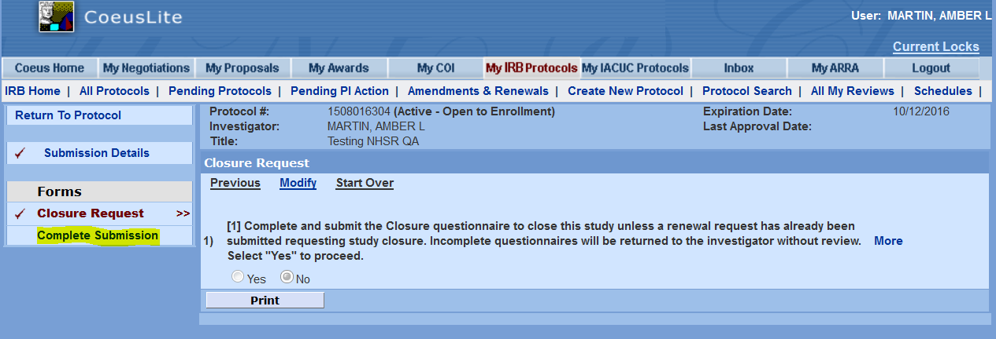
Select OK.
