COEUS LITE ONLINE SUBMISSION SYSTEM FAQs
- Where can I find my approved consent forms in CoeusLite?
  - For all protocols requiring Consent Forms, the the most recent approved consent forms, with watermark, can be found in the Attachments Tab. For any questions regarding these approved forms, please contact IRB-Questions@purdue.edu.
  - 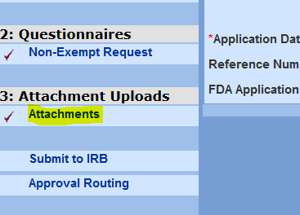
- Where can I find my approval letter in CoeusLite?
  - The approval letter for your protocol can be found in the protocol under the View History tab.
  - Expand on the Expedited Approval or Exemption Granted Protocol Action.
  - Under Correspondences, select View to see the Letter.
  - 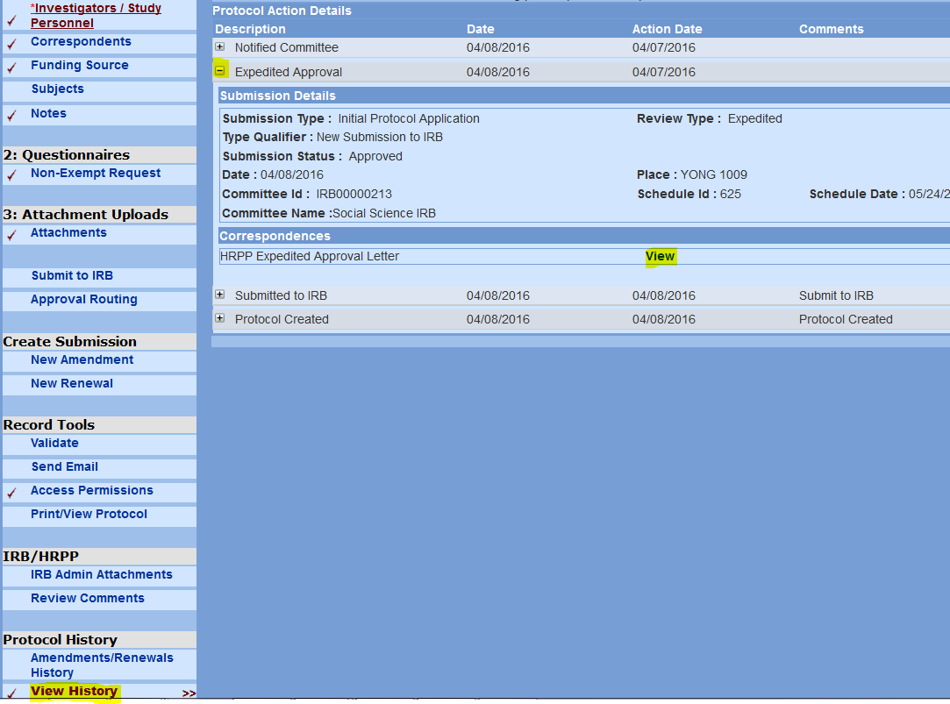
- What is my username and password for CoeusLite?
  - Your username and password are the same that you have set up for your Career Account at Purdue.
- I am listed on a number of protocols, but when I log in to the CoeusLite Online Submission System, I cannot see any of the protocols I am listed on.
  - All Principal Investigators and Co-Investigators should be able to view the protocols they are listed on. If you are not able to view a protocol or a number of protocols, please contact Coeus Help as a number of issues could be the matter. Please have your protocol number(s) handy to help them to assist you. (coeushelp@purdue.edu).
  - Key Personnel only have permission to view and/or edit if their Principal Investigator has given them permission through CoeusLite.
- Why can I not create a protocol?
  - Protocol creation should be initiated by the Principal Investigator of the study. If they wish to have another Faculty Member or Key Personnel complete the application, the Principle Investigator must grant those members Aggregator Access Permission of the protocol. In order to do this, the Principle Investigator needs to:
    - Create a New Protocol.
    - Under the General Information Tab:
      - Enter the submission type: Exempt, Non-Exempt
      - Enter the title of the study.
      - Select <Save>
    - Under the Access Permissions Tab:
      - Under Aggregator Role, select <Add User>
      - Search for the Faculty Member or Key Personnel
        - Remember to use asterisks before and after the name in the search field, for example, *smith*.
        - If the person is not available to select, contact Coeus Help to add them to the database. (coeushelp@purdue.edu)
  - If someone other than the Principal Investigator creates a protocol, amendment or renewal, it is imperative that they grant the Principal Investigator Aggregator permission.
- How can I make edits to my protocol?
  - Make sure you have been given Aggregator Access Permission by the Principle Investigator. (See previous bullet for instructions.)
  - Now that you are able to view your protocol, you may see something (or someone) on the protocol that needs to be changed or modified. Remember, any changes to the protocol need to be reviewed by the IRB via an Amendment. Depending on the type of protocol and the changes you wish to make, Amendments can take up to 14 Business Days for review (Full Protocols will be reviewed by the Board for the following meeting dependent on the date of submission and if it was prior to the submission deadline). Follow along in the Manuals(s) for further instructions regarding your Amendment.
  - You can create an Amendment via:
    - My IRB Protocols>IRB Home>Create New Amendment – OR –
    - My IRB Protocols>IRB Home>All Protocols>Select the protocol you wish to amend
      - >Create Submission/New Amendment
- I’m trying to upload attachments, but CoeusLite is not letting me.
  - Do you have Aggregator Access? Make sure you have appropriate permission to upload attachments under the Access Permissions tab.
  - Do you have two browsers open? Coeus will get confused and lock you out of your protocol – to check if you have locked yourself out, goto Current Locks in the top right corner of the screen and unlock any/all protocols you may have locked yourself out of.
  - Does it say someone else is in your protocol and you know that just is not true? Have you checked your locks and it says you haven’t locked yourself out? Contact coeushelp@purdue.edu and ask for help with unlocking your protocol.
  - Have you created an Amendment or Renewal and it is not allowing you to upload documents? Go back to the Amendment/Renewal Summary tab and make sure the Add/Modify Attachments box is checked at the bottom. Click Save and try to upload attachments again.
- I’m having trouble adding the Funding Source to my protocol.
  - Don’t forget to always use the asterisks before and after the Sponsor Name when using the search field. For example, to find the National Science Foundation, I would search under sponsor name>*national science foundation*. Once entered, the search field will populate a number of sponsoring agencies that relate to the sponsor you have entered. Please navigate around this screen to help you assign the best choice for your protocol.
  - If you continue to have trouble locating the sponsor through this method, please place a note in the Notes tab of the protocol with further details regarding your protocol funding.
- I’ve submitted my protocol to the IRB, how do I know where it is in the routing process?
  - When a protocol is submitted, the “Submit to IRB” link under 4: Submit will change to “Approval Routing”. When you select this link, you can see where your protocol is at in the routing process.
    - For exempt, amendment and renewal submissions, the protocol will need to be approved by the Principal Investigator before it can be forwarded on to the IRB. The Principal Investigator will receive an email with a link letting them know their protocol submission is waiting for their approval. You can see whether or not the Principal Investigator has taken this step in this tab as the status will state: Waiting for approval on the Principal Investigator Map. When the Principal Investigator has completed this step, the status will state: Approved.
    - For expedited submissions, in addition to the Principal Investigator approval, the Department Head will also need to approve the routing. They will not receive an email notification until after the Principal Investigator has approved their routing.
    - For Psychology - West Lafayette submissions, the Psychology Department performs pre-reviews on all submissions made by their department. Once the protocol submission has reached the IRB, the IRB will then route the protocol to the Psychology to complete their pre-review. When the Psychology Department has approved the pre-review, it will be routed back to the IRB where the IRB review process will begin.
    - When the IRB receives the protocol submission for review, a number of pre-review steps are taken before it can be routed to an Analyst. The #1 reason a submission is held up is due to lack of CITI training by the Principal Investigator or Key Personnel. Please make sure all CITI training is completed before submission.
- I’ve submitted my protocol, and now I want to make changes.
  - Once the protocol has been submitted and routed to the IRB, CoeusLite will lock the screen to view- or read-only and no further changes will be allowed. If your protocol was submitted in error, please notify the IRB so that we can reject your submission thus sending the protocol back to the Aggregator(s) for further changes. Please make sure all documents are uploaded and changes are made prior to submission. The IRB is only able to view one submission per protocol at a time. An exception to this would be that an Amendment and Renewal could be reviewed together if submitted together (within a 24 hour period).
  - If your submission has not reached the IRB for routing yet, you can go into your protocol under Approval Routing>Recall>Comments>Recall. This will put the protocol back in your hands for further changes before review.
- I have started creating an Amendment or a Renewal, but the Questionnaire will not “pop-up” in the left column of my protocol.
  - Anytime you create a new Amendment or Renewal, make sure to navigate to the General Info Tab and select <Save>. This will prompt the correct questionnaire to pop-up for your submission.
- I keep getting email notifications from Coeus – am I supposed to do something?
  - Since Coeus Lite went live on January 4th, the e-mail notification system was turned on. This notification system contacts the PI each and every time a new submission is routed in Coeus Lite. If you are entering a submission via the electronic system and you are the Principal Investigator, then you will receive an email asking for your approval. If you sent a submission to the HRPP-IRB Office via email or hard copy, they have bypassed the PI’s approval so two email notifications will be received (requesting approval, then bypassing approval).
- The questionnaire is asking me to submit an Application Narrative. What is this?
  - If you are submitting a Non-Exempt Application, and Application Narrative is a required attachment. The Application Narrative template can be found on the Forms Page of the IRB Website.
- Do I still need to attach the old paper application to my online submission?
  - The new CoeusLite Online Submission System replaces the old paper applications you are familiar with. Now, when submitting online, you will be asked to complete a questionnaire to help the IRB understand more details about your study and make the determinations needed for approval. If you have already completed one of the old applications, you are more than welcome to upload it into the Attachments tab to assist with your review.
- I have to upload a number of documents, can I just upload them all into one .pdf document?
  - Documents required for submission need to be uploaded separately to speed up IRB Review. It is possible that if your documents are not uploaded in a separate fashion the IRB will send back your submission further delaying review. Please refer to the CoeusLite Naming Conventions for Attachments on the Forms Page of the IRB Website to aid in uploading these documents correctly.
- CoeusLite is asking me to complete a Person Role Description for each of my Key Personnel – I do not understand what this is asking me to do?
  - The Person Role description is required for Study Personnel only. What we are looking for is a one-to-two word description of what that person’s role is in your study. Are they doing Data Analysis? Recruitment? Consenting? These are just examples of roles your personnel might perform in your study.

