Registration Instructions for CITI Training

Go to the Collaborative Institutional Training Initiative (CITI) website. On CITI’s home page click “Register” to create an account then complete Steps 1-7.
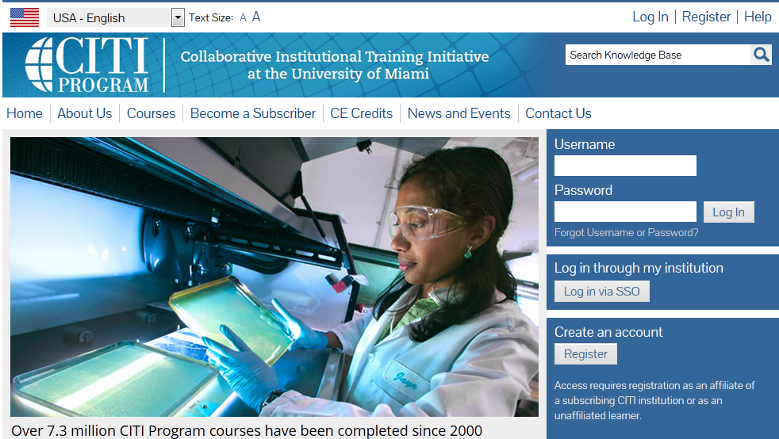

Step 1: Select Your Organization Affiliation

Begin typing “Purdue” in the text box. “Purdue University” should appear as shown in the screenshot below. Then click “Next” to continue to Step 2.
Investigators at IPFW, Purdue Calumet and Purdue North Central campuses should register under Purdue University for CITI certification. Failure to select Purdue University will prevent access to the required training which may delay IRB review of research submissions.
Non-Purdue investigators who are engaged in the conduct of a Purdue human subjects research study are welcome to affiliate themselves with Purdue University to fulfill Purdue’s education requirement.
Steps 2 – 5: Complete the required fields.
Step 2: Personal Information (name & email address)
Step 3: Create you Username and Password*
*The username and password you register with CITI is solely for the CITI program and not related to or linked to Purdue University user accounts. If you forget your user name or password, contact CITI for assistance.
Step 4: Gender, Ethnicity and Race
Step 5: Continuing Education Unit (CEU) credit
Step 6: Information Requested by Purdue University:
Users should provide the email address associated with their Career Account to ensure that both CITI completion credits are applied to the correct individual and they receive pertinent information related to the CITI certification such as expiration notices, etc.
Step 7: Select Learner Group
Question 1 asks Users to select the curriculum (called Learner Groups) they wish to complete to fulfill the Basic Course requirement. At a minimum, Users must select and complete the Learner Group that corresponds with their role in the research. However we strongly recommend that all Users, regardless of their role in the research, complete either:
- Biomedical Research for Investigators and Key Personnel Learner Group, or
- Social Behavioral Research for Investigators and Key Personnel Learner Group.
Please see our guidance Research Roles and CITI Learner Groups to learn about each of Purdue’s offered Learner Groups.
