Registration Instructions for CITI Training
Step 1:
Go to the Collaborative Institutional Training Initiative (CITI) website. On CITI’s home page, click “Register” to create an account for the first time.
If you have a Purdue University Career Account, click “Log In Through My Institution” and use your Career Account to access CITI courses. Those without Purdue Career Account Credentials must register for CITI by creating a new CITI account.
*If this is the first time you have logged in using your Purdue Career Account, CITI will prompt you to link any CITI accounts*
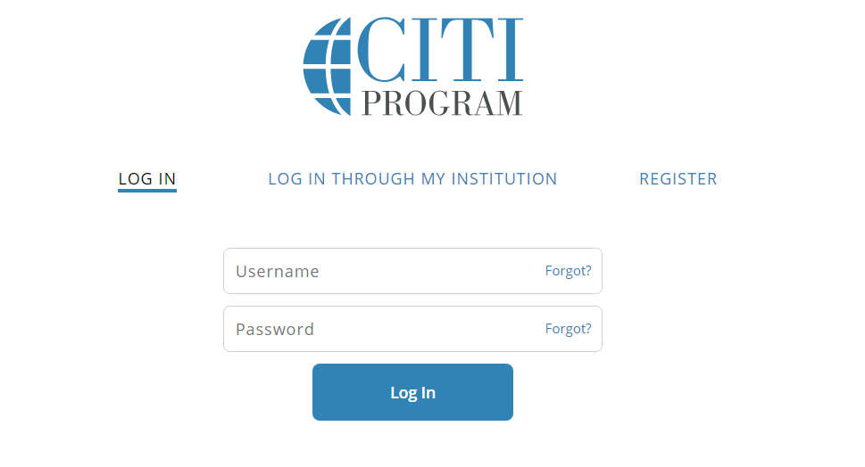

Step 2:

Be Certain to Select an Organization Affiliation with Purdue University

Begin typing “Purdue” in the text box. “Purdue University” should appear as shown in the screenshot below. Then click “Next” to continue to Step 2.
Investigators at Purdue Fort Wayne and Purdue Northwest should register under Purdue University for CITI certification. Failure to select Purdue University will prevent access to the required training. Training discrepancies may delay IRB review of research submissions.
If you are a Purdue researcher who completed your CITI training at another institution, you can transfer your certification to Purdue by selecting “Affiliate with Another Institution” on the user menu.
Non-Purdue investigators who are engaged in the conduct of a Purdue human subjects research study are welcome to affiliate themselves with Purdue University to fulfill Purdue’s education requirement. With this additional listing of affiliation, Purdue HRPP staff can access your training records.
A researcher who does not have current equivalent training from another institution, can either obtain certification from his/her own institution so long as it is equivalent to Purdue’s required training, or the researcher can complete Purdue’s CITI training by following the instructions above, Training for New Users.
Step 3: Select a Learner Group
Users must select and complete the Learner Group that corresponds with their research. Training must occur in the Human Subjects Research - Initial (Basic) Training Courses to fulfill IRB/HRPP requirements.
- Biomedical Research for Investigators and Key Personnel Learner Group, or
- Social Behavioral Research for Investigators and Key Personnel Learner Group.
***Those who have previously taken training may be eligible for a Refresher course, provided that the training was completed no greater than four years ago.***
Step 4: Complete Training
Complete all modules of the selected training. You must score an 80% to pass training and review the Purdue University Institutional page. NOTE: Responsible Conduct of Research (RCR) training does not fulfill Purdue’s human subjects research training requirements.
Step 5: Keep Records
The Principal Investigator of a study must maintain training records on any IRB protocol. Keep a record of CITI training (through the provided Certificate of Completion) in all study records.

